Directory of Librarians, Library Science Teachers and Library Staff

Full Name – Prof. Ajit Janardan Rangdal

Date of Birth – 13/05/1987

- Education – M.A., M.Lib.&I.Sc., NET
Graduation/ Post Gratuation | University | Passing Year
B.A. | Dr. BAM, University, Aurangabad. | 2007
M.A. | Dr. BAM, University, Aurangabad. | 2010
B.Lib.&I.Sc. | YCMO University, Nashik. | 2009
M.Lib.&I.Sc. | YCMO University, Nashik. | 2010

- Library Science Education –
Course | University | Passing Year
LTC | Mumbai | 2005
B.Lib.&I.Sc. | YCMO University, Nashik. | 2009
M.Lib.&I.Sc. | YCMO University, Nashik. | 2010
M.Phil | -
P.hd | -

- Experience –
Institute/College | Post Held | Years

Professional Experience: 5 Year
- Established Computerised Library in Shrikrishna Mahaidhyalaya Library, Gunjoti Tq: Omerga Dist: Osmanabad (MH) and assisted in entering 10,000 entries.
- Worked as an Lecturer & Library Asst. in Shri Kumarswami Mahavidhyalaya, Ausa Dist: Latur(MH) From 16 June 2008 to 25 Jan 2012.
- Worked as an Library Asst. in Sou. Suvarnalata Gandhi Mahavidhyalaya, Vairag Tq: Barshi Dist: Solapur (MH) From 01 Feb 2012 to 31 Aug 2012.
- Working as an Librarian in Shri Havagiswami Mahavidhyalaya, Udgir Dist: Latur(MH) From 14 May 2013 to till date.
Give Details -
- Number of Publications – Books If any,
Publications:
Book: 01
Research Paper: 06
Book:
- Contributed as Co-Editor towards the publication of a book titled ‘Granthalaya Vyavasthapanachi Aadhunik Tantre’: 2012, Aruna Prakashan, Latur. ISBN 978-93-81190-82-1.
Research Papers Published in Journals/Conference/Seminar/Souvenir/Proceeding:
Sr.  No. | Name of Authors | Year | Title of Paper | Name of Symposia / Conference | Sponsoring Agency
1 | A. R. Kaldate,  A. J. Rangdal,  S. J. Deshmukh,  P. B. Ghante | 2010 | Gunvattapuran Shikshan v NAAC Mulyakan Parkriyat Grantalya MahithiSevechi Bhoomika | NAAC New Methodology of Assessment & Accreditation (28 March 2010), SCSC, Omerga | UGC, New Delhi
2 | A. J. Rangdal,  B. V. Chalukya | 2012 | World Wide Web Digital Libraries | Empowering Libraries For Lifelong Learning Skills (17th& 18th August 2012) PDA College of Engineering, Gulbarga. | Gulbarga Division Libraries Association &  Karnataka State College Librarians Association
3 | A. J. Rangdal,  S. M. Deokar | 2012 | Six Sigmache Granthalayat Upyojan | Application of Modern Management Techniques in Academic Libraries : Problems & Solutions (7th Oct. 2012) Rajrshi Shahu College, Latur. | V. R. Dadge Gaurav Samiti, Latur.
4 | A. J. Rangdal,  Y. P. Surwade,  J. N. Kulkarni | 2012 | Digital Library | Application of Modern Management Techniques in Academic Libraries : Problems & Solutions (7th Oct. 2012) Rajrshi Shahu College, Latur. | V. R. Dadge Gaurav Samiti, Latur.
5 | A. J. Rangdal,  A. R. Kaldate,  S. M. Deokar,  B. V. Chalukya, | 2012 | Umarga Talukyatil Mahavidhyalaya Granthalayatiil Vachansahitya Sangrahacha Vikas Ek Abhyas | Libraries from Palm Leaf to Paper Less (13th Oct. 2012) Dr.Sau.K.G.I.E.T., Darapur | Library & Information Science Study Circle, Amravati.
6 | A. J. Rangdal,  S. M. Deokar | 2012 | Six Sigma | Research Libraries : Need of the Time (13th& 14th Oct. 2012) Deogiri College Aurangabad. | UGC, New Delhi

________________________________________________________________________________
- Articles in conferences (Name, Year, Place, Title of Paper)
________________________________________________________________________________

_________________________________________________________________________________
- International Conferences Attended – (Name, Year, Place, Title of Paper)
Conference, Seminar, Workshop, Webinar Attended: 14
National Conference | National Seminar | National Workshop | Webinar
03 | 06 | 03 | 02
Details of attended Conference, Seminar, Workshop, Webinar:
National Conference Attended:
- Attended Two days National Conference on “Innovative Practices in LIS Education & Services in the Present Era” Sponsored by UGC & Organized by Learning Resource Center, Dayanand Arya Kanya Mahavidhyalaya, Jaripatka, Nagpur-14 (MH) on dated 27th & 28th July 2012.
- Attended Two days National Conference on “Empowering Libraries for Lifelong Learning Skills” Sponsored by Gulbarga Division College Librarian’s Association & Karnataka State College Librarian’s Association & Organized by HKE’s Poojya Doddappa Appa College of Engineering, Gulbarga (KA) on dated 17th & 18th Aug 2012.
- Attended One day National Conference on “Libraries-From Palm Leaf to Paperless” Sponsored by Library and Information Science Study Circle, Amravati & Organized by Department of Library Science, Dr. Sau. Kamalatai Gawai Institute of Engineering & Technology, KGIET, Darapur Tq: Daryapur Dist: Amravati (MH) on dated 13th Oct 2012.
National Seminar Attended:
- Attended Two days National Seminar on “Dr. Ramkumar Varma Janmashati” Sponsored by UGC & Organized by Department of Hindi, Ramakrishna Paramhans Mahavidyalaya, Osmanabad Dist: Osmanabad (MH) on dated 6th& 7th Feb 2005.
- Attended Two days National Seminar on “Dr. Hariwanshroy Bacchan & Dr. Ramdharisinh Dinkar Janmashati” Sponsored by UGC & Organized by Department of Hindi, Shrikrishna Mahavidyalaya, Gunjoti Tq: Omerga Dist: Osmanabad (MH) on dated 7th& 8th Jan 2008.
- Attended Two days National Seminar on “Recent Advancements In Library And Information Science” Sponsored by UGC &Dr. Babasaheb Ambedkar Marathwada University, Aurangabad and Organized by Shrikrishna Mahavidyalaya, Gunjoti Tq: Omerga Dist: Osmanabad (MH) on dated 11th & 12th Jan 2010.
- Attended Two days National Seminar on “Gandhiji’s Constructive Programmes for Social Development” Sponsored by UGC & Organized by Gandhian Studies Centre, Shrikrishna Mahavidyalaya, Gunjoti Tq: Omerga Dist: Osmanabad (MH) on dated 25th & 26th Mar 2011.
- Attended One day National Seminar on “NAAC’s New Methodology of Assessment & Accreditation” Sponsored by UGC & Organized by Shri Chhatrapati Shivaji College, Omerga Dist: Osmanabad (MH) on dated 28th Mar 2010.
- Attended One day National Seminar on “Latest E-Library Management Tools And E-Book Collections” Sponsored by EBSCO & Organized in MIT School of Management, Pune (MH) on dated 31st Aug 2012.
National Workshop Attended:
- Attended One day National Workshop on “User Awareness Program on Access to e-Resources under N-List (National Library and Information Services Infrastructure for Scholarly Content) Program” Sponsored by UGC-INFLIBNET & Organized by Department of Library and Information Science Center, St. Ann’s College for Women, Mehdipatnam, Hydrabad-28 (A.P.) on dated18th July 2012.
- Attended One day National Workshop on “DELNET : Resources, Services & Facilities” Sponsored by DELNET (Developing Library Network, New Delhi)& Organized in collaboration with Malla Reddy Engineering college, Secunderabad at Malla Reddy Engineering college, Secunderbad (AP) on dated 13th Aug 2012.
- Attended One day University Level Workshop on “New Trends in Library & Information Science” Organized by Dayanand Education Society’s in collaboration with Swami Ramanand Teerth Marathwada University, Nanded at Dayanand College of Arts, Latur (MH) on dated 16th Dec 2012.
Webinar Attended:
- Attended One day Webinar on “Cloud Era” This event is powered by Citrix Online, 7414 Hollister Avenue, Guleta, CA 93117 on dated 24thAug 2012.
- Attended One day Webinar on “Is Your Data Protection Strategy Good Enough?” Sponsored by ISACA’s Data Protection Webinar & Organized by India Professional Community 3701 Algonquin Road, Suite 1010, Rolling Meadows, Illinois 60008 USA on dated 20 Sep 2012.

- Award Details – Year ______________________________________________________________
- Mobile - 09270307002 E-Mail ID ajitrangdal@gmail.com
- Tel. No.Off./Home__________________
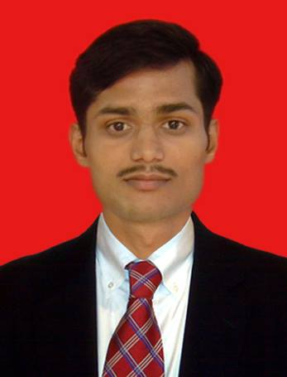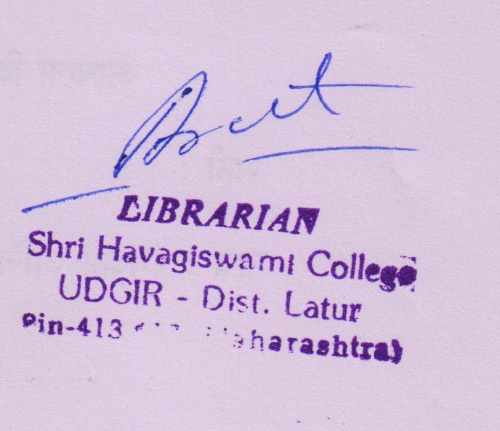

Signature

(Please send Photograph along with the form to E-Mail ID- mahajansg1958@gmail.com or
to Dr. S. G. Mahajan, Plot 27, Swastishri Society, Ganesh Nagar, Pune-411052. )

